Assignment OSFP

*Name: Mahnoor Arshad*

*Class: Se-5B Roll: Se-221027*

*Course:* ***Computer Networks***

*By* ***Sir Wilayat***

**1. Overview of the Topology**

The provided network topology consists of:

* **Three Routers (Router0, Router1, Router2)**
* **Two Switches (Switch0, Switch1)**
* **Four PCs (PC0, PC1, PC2, PC3)**

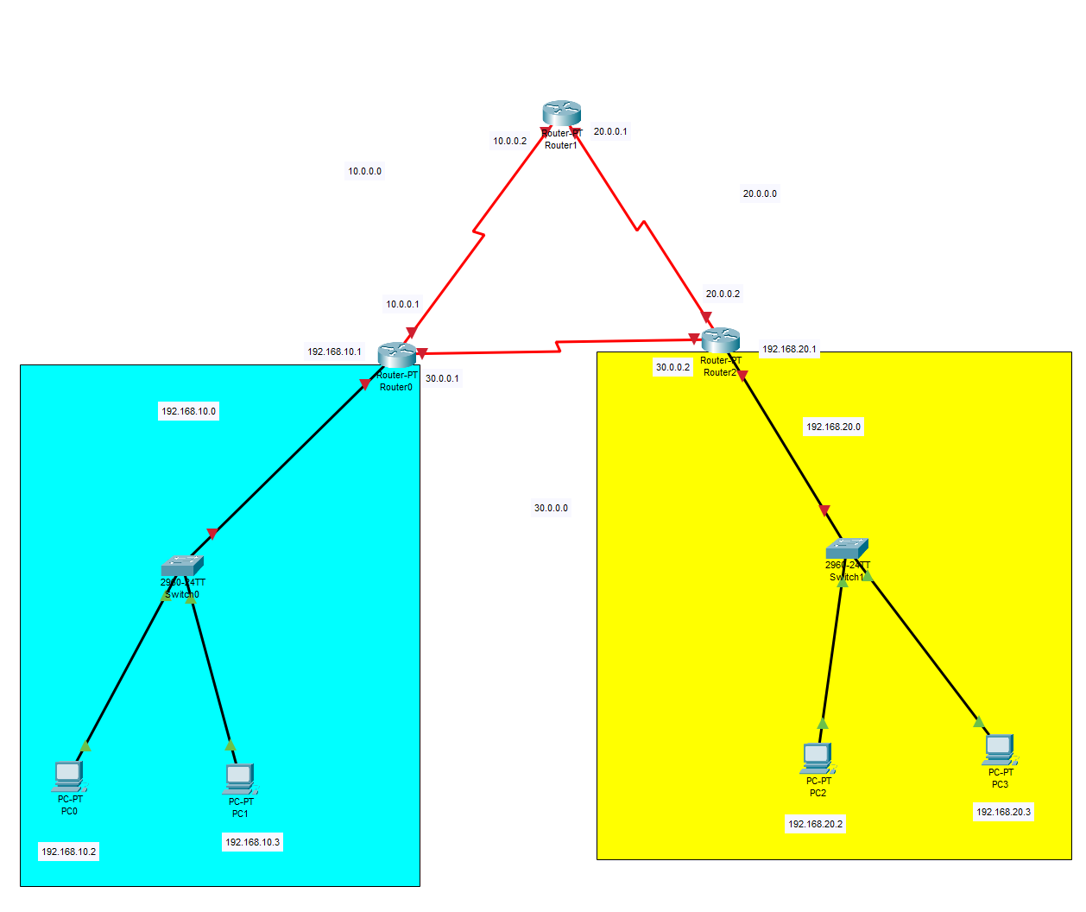  
  
  
**OSPF (Open Shortest Path First)** is a **dynamic routing protocol** that helps routers share and update network information efficiently. It is a **link-state protocol.**  
Router Configuration:  
  
  
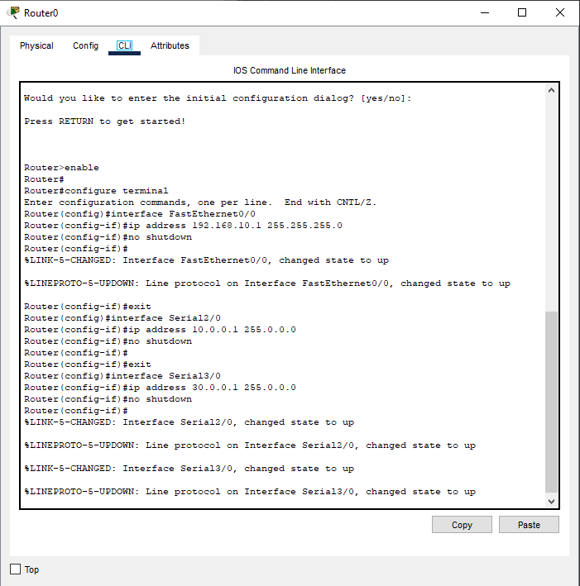  
  
  
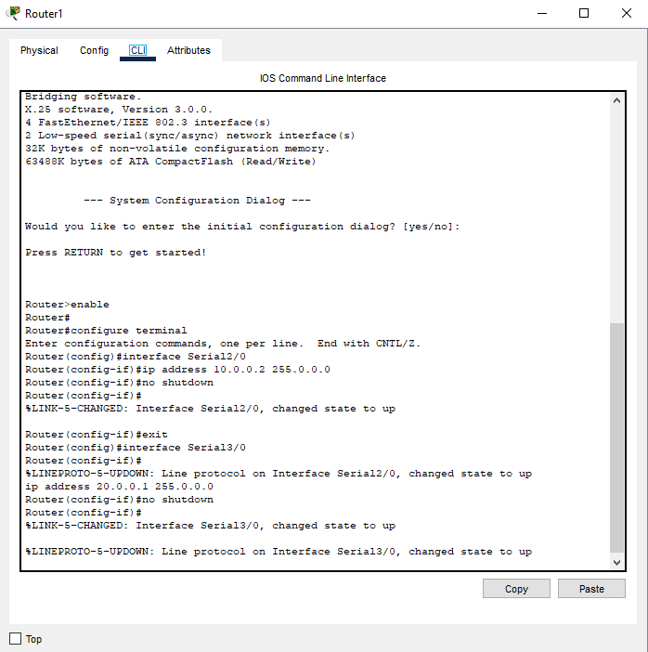  
  
  
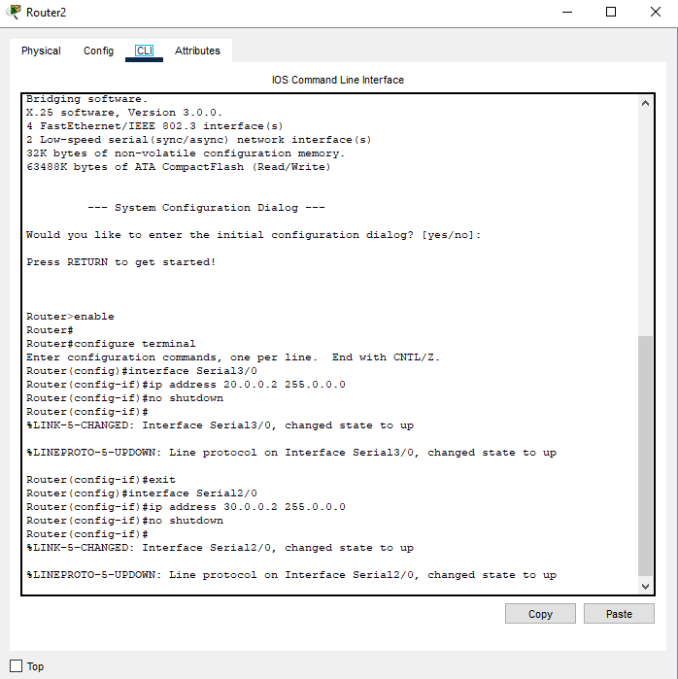  
  
  
  
  
  
  
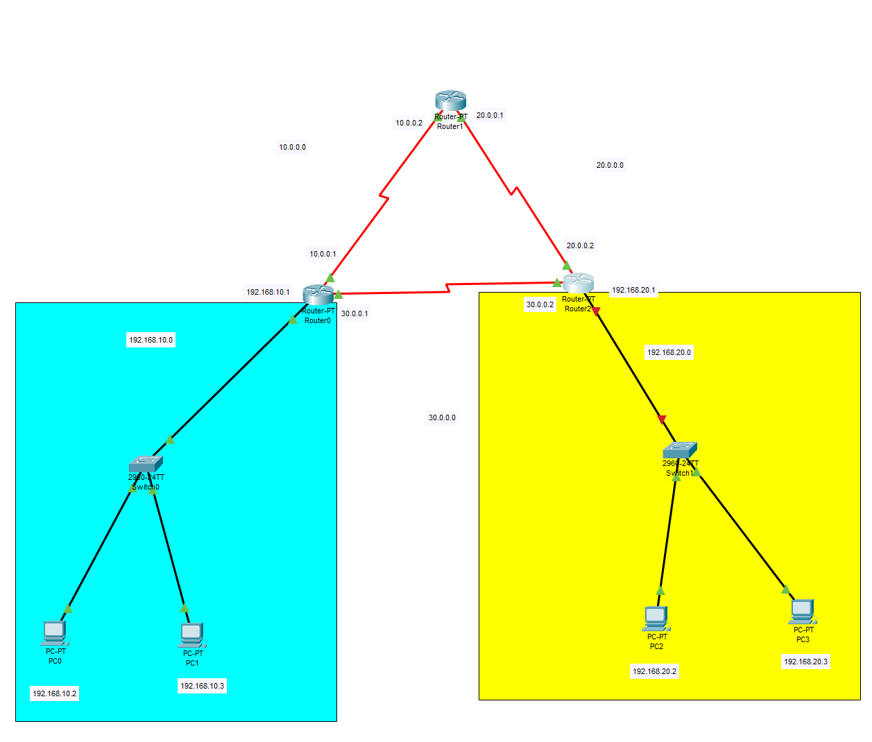  
  
  
  
  
  
  
  
  
  
  
  
  
OSFP Configuration:  
  
  
  
  
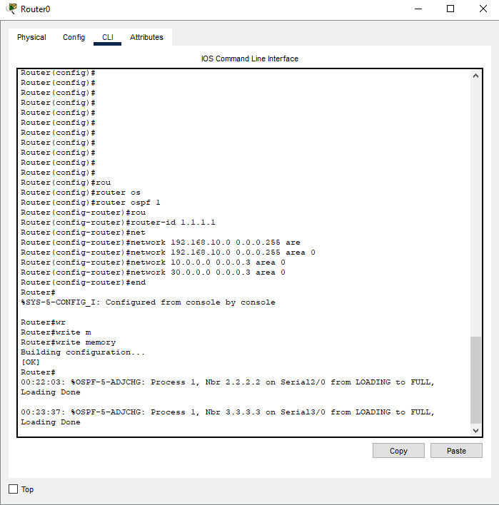  
  
  
  
  
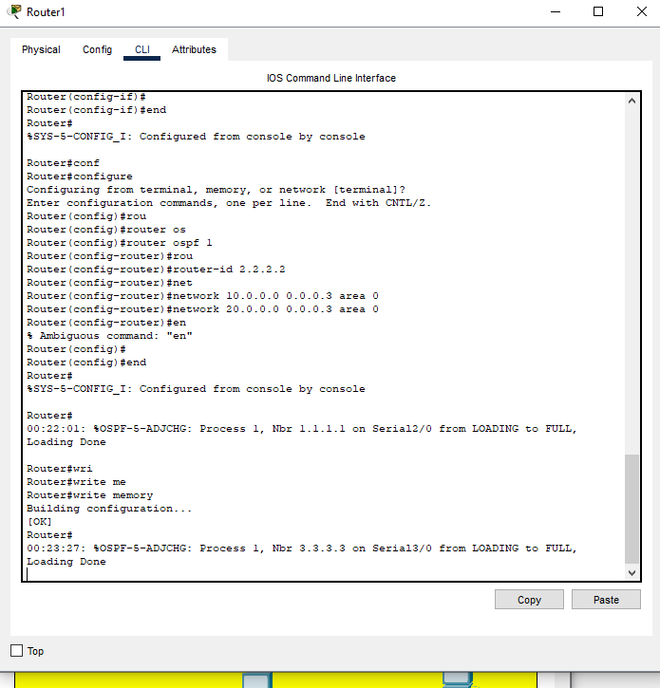  
  
  
  
  
  
  
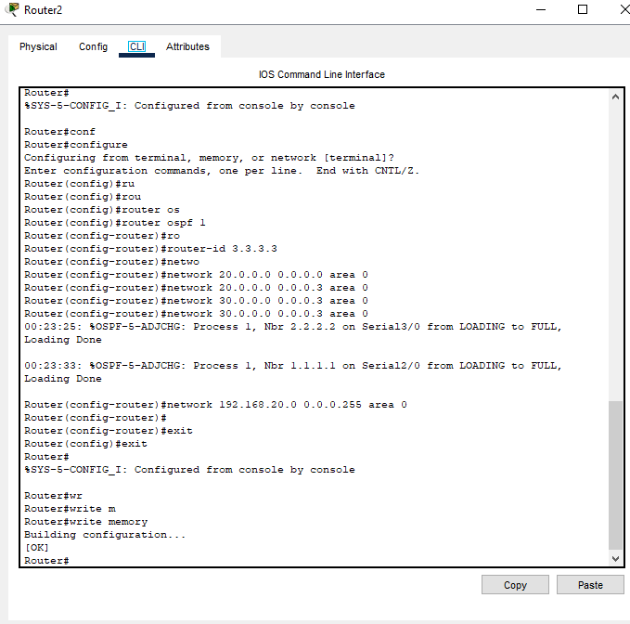  
  
  
  
  
  
  
  
  
  
  
  
Verify OSPF Configuration:  
  
  
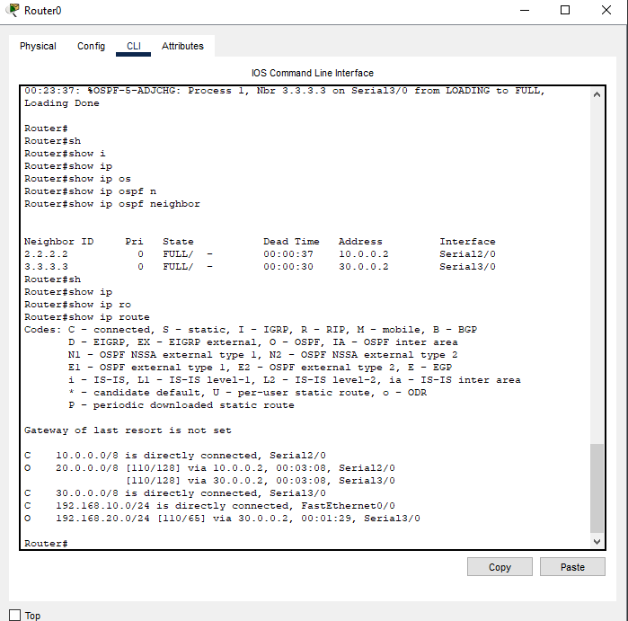  
  
  
  
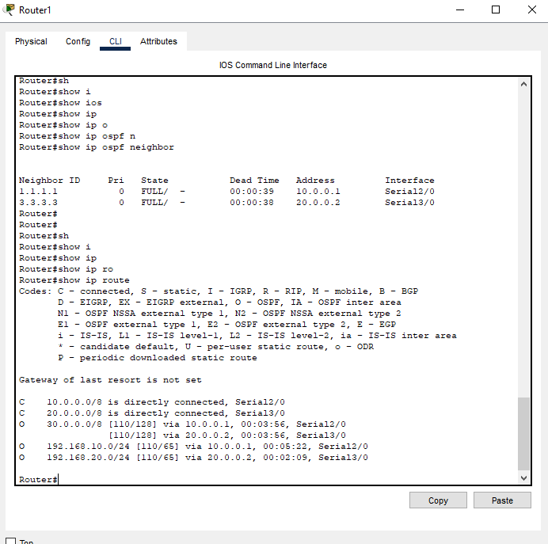  
  
  
  
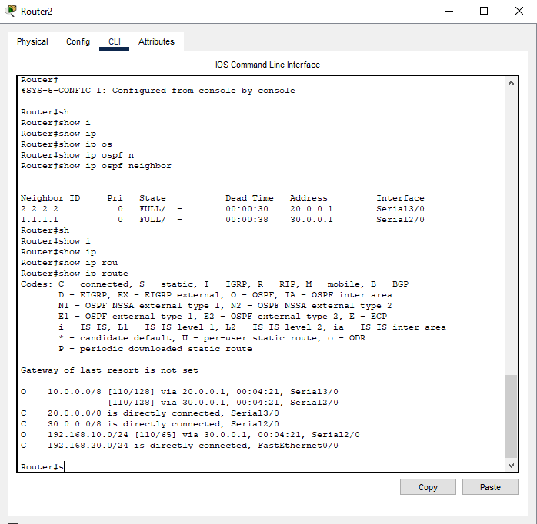  
  
  
  
  
  
  
  
  
  
  
Testing Connectivity  
  
From PC0 (192.168.10.2) to PC2 (192.168.20.2  
  
  
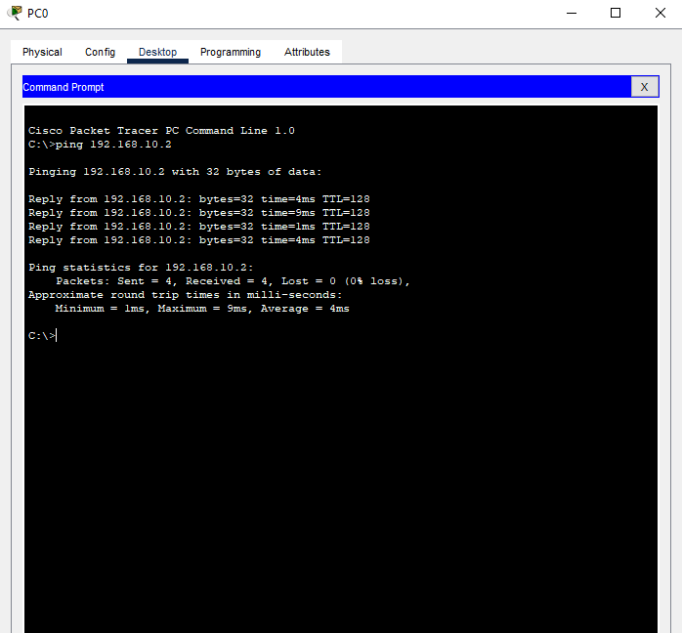  
  
  
  
  
the **successful pings and routing table validation demonstrate that OSPF was correctly implemented and is functioning as expected**. The routers are dynamically sharing routing information, allowing seamless communication between all devices in the network. This setup ensures efficient routing, redundancy, and scalability, making OSPF an effective choice for this network topology